# Application Programing Interface (API)

# ABOUT WEB DEV

* CLIENT – SERVER
* HTTP
* MODEL – CONTROLLER - ROUTER

# CLIENT - SERVER

FRONT-END | BACK-END

API

## BUILD YOUR FIRST API – Steps to do

* Choose back-end language
* Set-it-up in the localhost
* Connect to the Database
* Routing
* Test your API

## TUTORIAL

Use Node.js to create a REST API

### PAGE DESCRIPTION

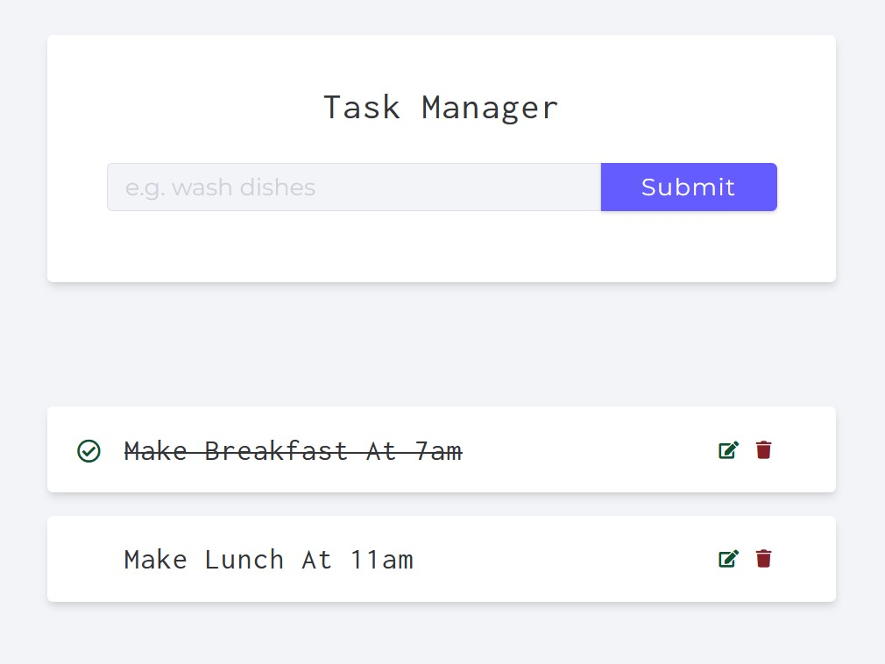

INSTALLATION

* Node.js
* MongoDB
* IDE

### LOCALHOST SERVER

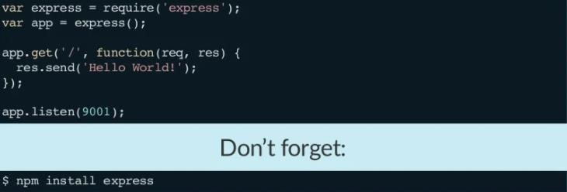

### CONNECT AND CREATE Database

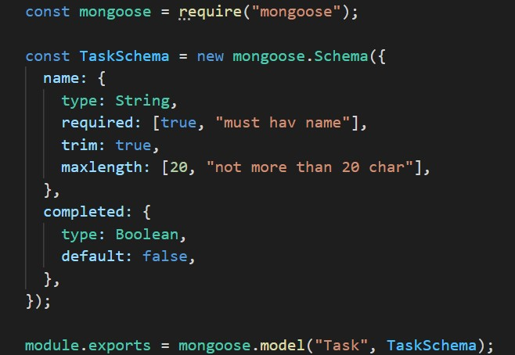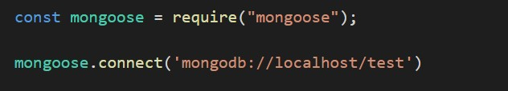

### ROUTES to your API

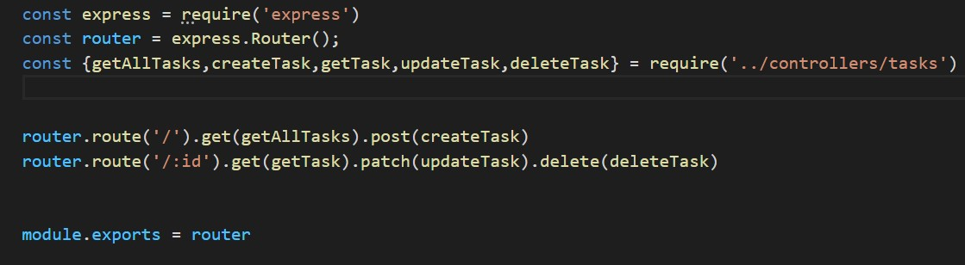

TEST your API

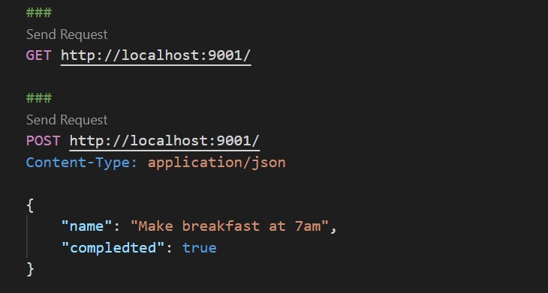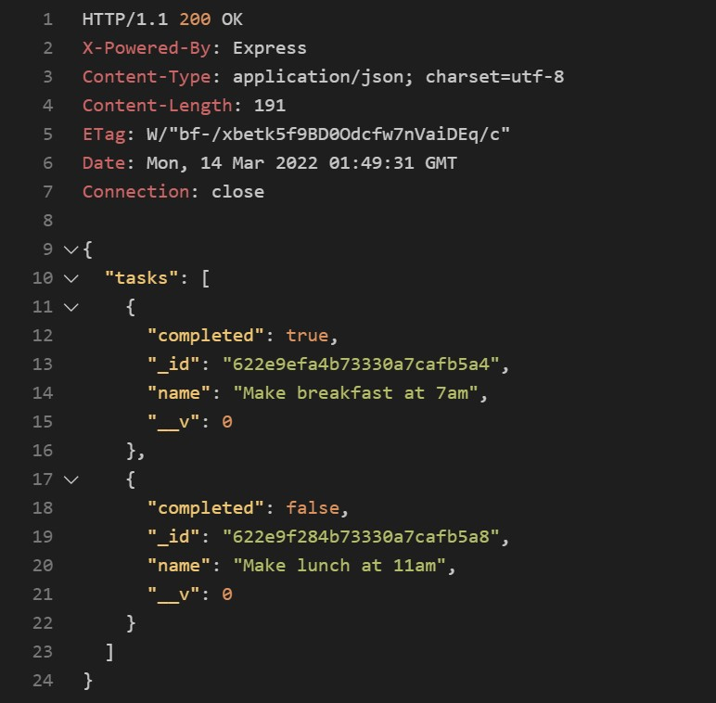

# GO FURTHER

* https://nodejs.org/en/docs/
* https://mongoosejs.com/docs/api.html

Authentication & Authorization

# SOFTWARE SECURITY

* Software security should always be a high priority for product developers and their users
* If you don’t prioritize security, customers will inevitably suffer lossed from malicious attacks
* Worst case scenario, product providers out of business
* Recover from the attacks take time and effort
* *Examples: unauthenticated users* | *unauthorized users*

# AUTHENTICATION

* Authentication is the process of ensuring that a user of your system is who they claim to be
* Authentication is needed in all software products that maintain user information, so that only the providers of that information and access and change it
* Also, use authentication to learn about users. Hence, personalize their experience of using the products

# AUTHENTICATION APPROACH

* Knowledge-based:
* 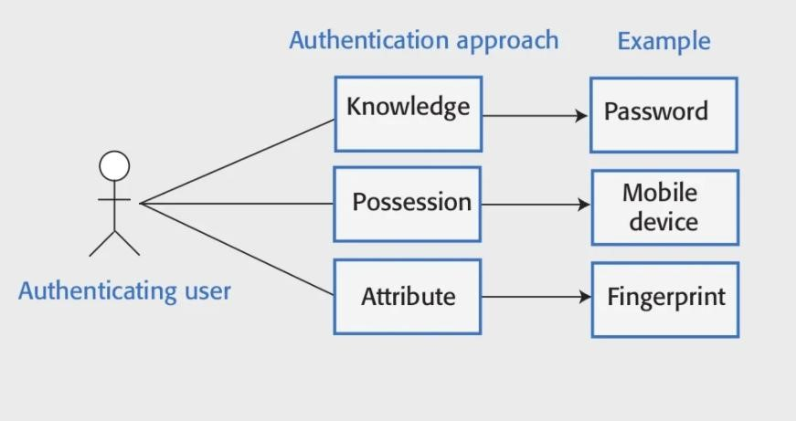The user provides secret, personal info to register. On logging in, the system asks them for this info
* Possession-based:
* This relies on the user having a physical devices that can generate or display info that is known to the authenticating system. The user input is info to confirm the authentication
* Attribute-based:
* Base on a unique biometric attribute of the user such as fingerprint
* Multi-factor

*

# Authentication using an external authentication service

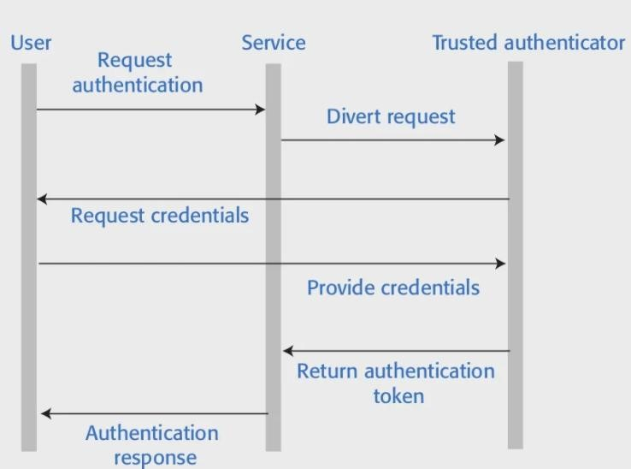

# AUTHORIZATION

* Authorization is a complementary process in which that identity is used to control access to software system resources
* for example: a doc on Google Drive, the document’s owner may authorize you to read the content but not to edit the content
* Authorization is based on an access control policy

# Access control lists

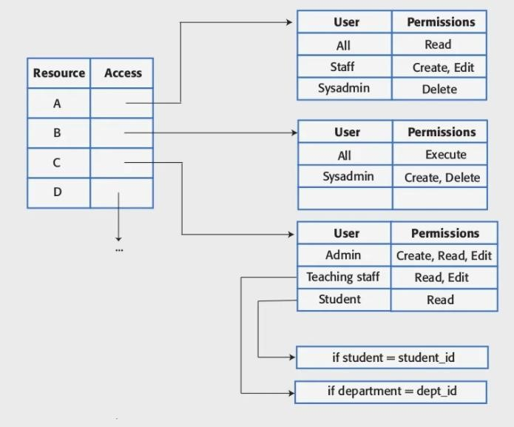

# TUTORIAL

Using *bcrypt* and jwt to create login/register API

TASK MANAGER

* 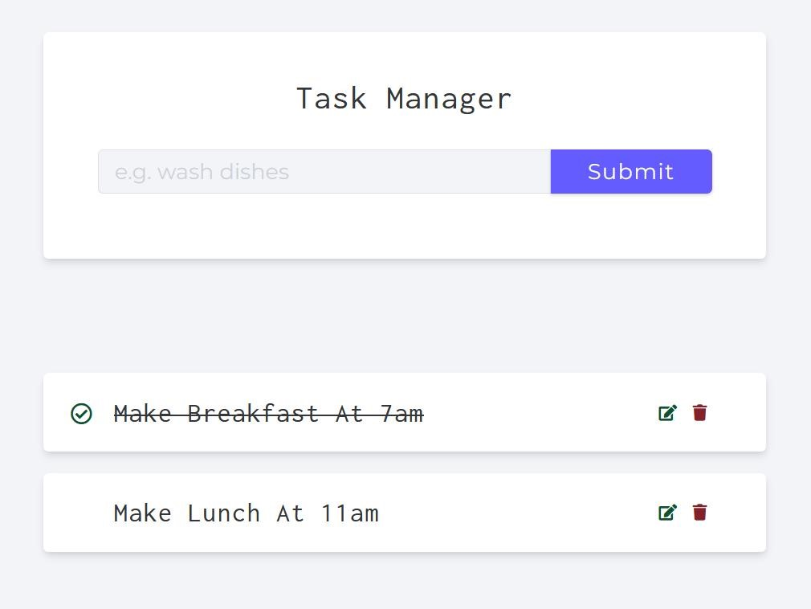Functionality: Manage tasks for a specific user, who is able to register for an account.
* The user should provide at least two kinds of information: username and password
* Authenticate users by their encrypted password
* Authorize users to accsess only their tasks.

INSTALLATION

* *npm install bcryptjs*
* *npm install jsonwebtoken*

## PASSWORD ENCRYPTED

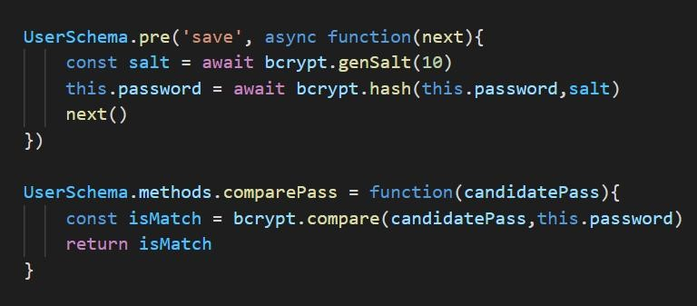

## jsonwebtoken

* Authorize user to access specific APIs by token
* Once the user is logged in, each subsequent request will include the JWT, allowing the user to access routes, services, and resources that are permitted with that token

GENERATE TOKEN

* SECRET KEY

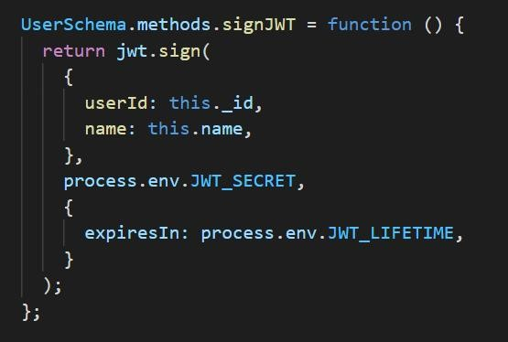

* Sign with *jwt*  to generate token
* Transmitting data between client and server with the generated token

# TEST YOUR APIs

# GO FURTHER

* https://www.npmjs.com/package/bcryptjs
* https://jwt.io/introduction